Biomechanical analysis of pedicle screw reinsertion along the same trajectory in a 3D printed synthetic bone model
Graham Mulvaney, MD
Christopher Holland, MD, PhD
Michael A. Bohl, MD
2023-08-31
Abstract
Background: The Carolina Neurosurgery Spine Biomechanics Laboratory has previously validated a 3D printed synthetic bone model for biomechanical testing. This model has demonstrated comparable biomechanical properties to cadaveric vertebrae, but with improved reproducibility and standardization. This study aims to investigate the biomechanical properties of pedicle screw reinsertion along the same trajectory in this model.
Methods: Twenty biomimetic 3D printed PLA models of lumbar vertebrae were printed, and twenty screws were placed into each arm. Pullout strength, screw stiffness, and strain energy were calculated. Statistical analysis was performed using a two-tailed t-test to generate p-values.
Results: Mean pullout strength demonstrated 760 +/- 70 N in the control arm vs 725 +/- 66 N in the test arm(p=0.3). Mean stiffness showed 538 +/- 83 N vs 539 +/- 133 N (p>0.9). Mean strain energy showed 1821 +/- 445 Nmm vs 1823 Nmm +/- 327 Nmm (p>0.9). There was no significant difference between pullout strength, stiffness, or strain energy.
Conclusions: This experiment demonstrates there is no loss of pedicle screw purchase when a screw is removed and reinserted along the same trajectory. This experiment shows the highest precision of any prior study in a low-cost highly-reproducible model.

Introduction
Pedicle screw fixation has been utilized in an increasing manner for the surgical management of various spine diseases since it’s general adoption in the 1990s. Key early studies evaluating their effectiveness and robustness have remained a steady undercurrent of the steady advancements that have enabled expansions of use and the extension of meaningful surgical correction of increasingly complex pathologies. Outside of clinical trials, the most instrumental and influential studies have sought to define the biomechanical parameters that can most effectively be augmented to increase their effectiveness. Studies have since identified and centered around maximizing screw purchase within the bone, decreasing the propensity for the screw to break, and decreasing the chance for the screw to pullout of the bone or loosen. These are the most common failure points for screw-rod constructs and are known to lead to both pseudoarthrosis and mechanical back pain, often leading to the need for revision surgery or extension of constructs.
The pullout strength of a screw is a biomechanical parameter that encompasses all of these principles in a meaningful way. Additional measures that have been previously analyzed for correlation to pullout strength include the stiffness of the construct, which is a measure of a screws resistance to deformation, the insertional torque (a sign of increased screw purchase), and the strain energy associated with removal (useful to compare for screw constructs of varying stiffness).
These fundamental biomechanics underpinning pedicle screw fixation have been investigated for decades. Among the investigations of these fundamental studies have directly led to innovations including cement augmentation, cortical bone trajectory placement, and a plethora of screw and tulip head variations. Since these initial breakthroughs however, impactful biomechanics studies have decreased and meaningful results have diminished.
The rate of surgical device innovation has only accelerated in the meantime, and with the increasing implementation and evolution of techniques such as navigated systems, it is clear that an improved model with better reproducibility and generalizability is necessary. Additionally with the forecasted wave of osteoporosis and metastatic tumor due to increasing patient age and survivability with cancer diagnoses, we can expect an increased number of screw adjustments and revisions from initially poor placement in the coming years as surgeons adapt to new learning curves.
With these coming tribulations, there are new critical questions that will arise that are lacking a clear paradigm for investigating. An example of this question is, regardless of technique placing a screw, if a surgeon places a screw, removes said screw to assess the integrity of the pedicle, and finding it suitable, places the screw back into place via the same trajectory and angle, is this screw inherently weaker? This question has been investigated by only a handful of biomechanics labs, which should be lauded for continuing this research and providing compelling evidence of their results in varying substrate. However, the inherent cost of these models, the lack of generalizability, and ultimately the wide variation in the primary outcomes of each study makes it incredibly difficult to correct for sampling bias and to reject the null hypothesis.
A novel 3D printed model of a lumbar vertebral body has previously been validated, with demonstrations of similar resistance to load, closer reproduction of screw placement feel, as well as possessing a generalizabilty to the population at large in an increasingly globalized world with ready access to 3D printers. This study aims to provide a robust analysis of the biomechanics of pedicle screw reinsertion, and we hypothesize that there is no difference in strength when the reinsertion trajectory is the same.

Methods
Institutional review board approval and patient consent was not required because no patients were involved in this study. This study was performed within the Carolina Neurosurgery and Spine Biomechanics Laboratory utilizing a 3D printed biomimetic model of a lumbar vertebrae, previously described and validated by Hani et al. A lumbar vertebra was converted to an “.stl” file from a high-resolution CT prior to utilization of Simplify3D(citation) to isolate and standardize a pedicle trajectory for all models used in this study. A was used to print every model used as a polylactic acid (PLA) mounting block based on the initial “.stl” file. All lumbar vertebral models were printed from the same .stl files and were anatomically identical.
Twenty models were designed and printed via this technique, and 10 were placed into a control arm and testing arm each. Ten screws were then placed into a control arm and a testing arm. In the control arm. Every screw used in the study was . Each screw was inserted to <was undertapping used?>. In the control arm the screws were inserted once prior to pullout. In the testing arm, the screws were unscrewed once prior to being re-screwed in and pulled out. Both arms measured force [N], displacement [mm] and time [s], while the testing arm also measured insertional and removal torque. In these models, a through direct force applied along the same trajectory as insertion. Measurements included pullout strength, displacement, and initial and secondary insertional torques. Force-displacement graphs were generated for each screw. The Mesur Gauge software was used for collection.
This study utilized a validated 3D printed synthetic vertebral body model as described in prior work. Twenty identical models were printed using polylactic acid (PLA) material on an Ultimaker 2+ 3D printer (Ultimaker B.V., Netherlands).
Pedicle screws were placed into the L4 vertebral body models. The control arm (n=10) involved inserting screws to full depth before immediate removal. The test arm (n=10) involved inserting screws to full depth, controlled removal, reinsertion to the same depth along the original trajectory, then forcible removal via direct axial pulling.
Outcomes included maximum pullout force, stiffness, and total strain energy to pullout. Stiffness was calculated from the linear elastic region of the force-displacement curves. Welch two sample t-tests were performed in RStudio to compare outcomes between arms. Statistical significance was set at alpha = 0.05. Statistical analysis and data visualization was performed using RStudio, R language .
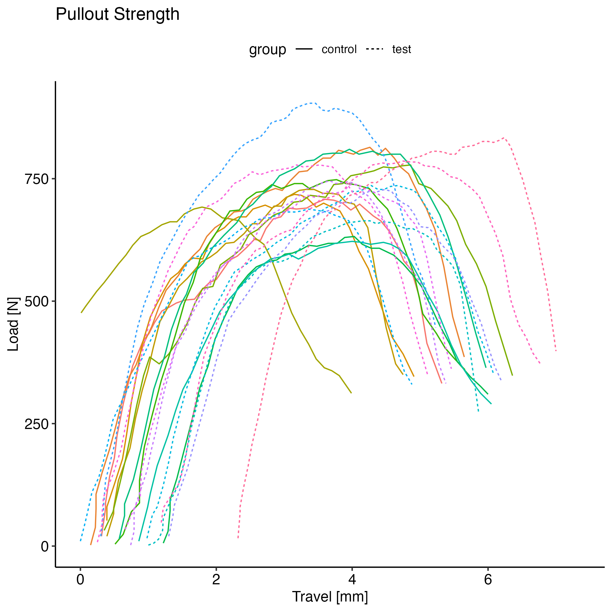 | 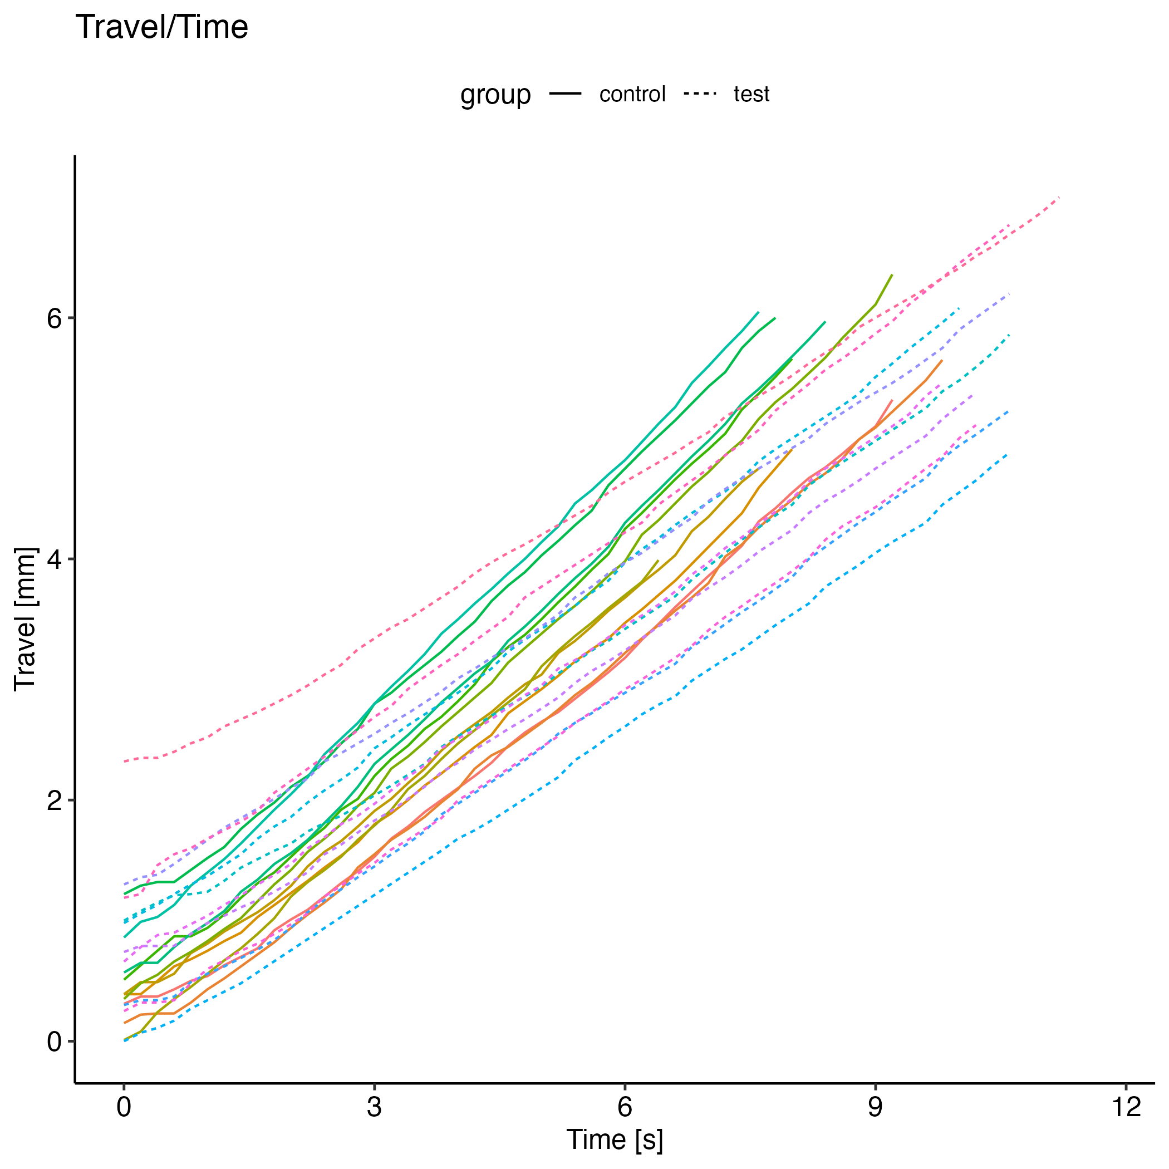 | 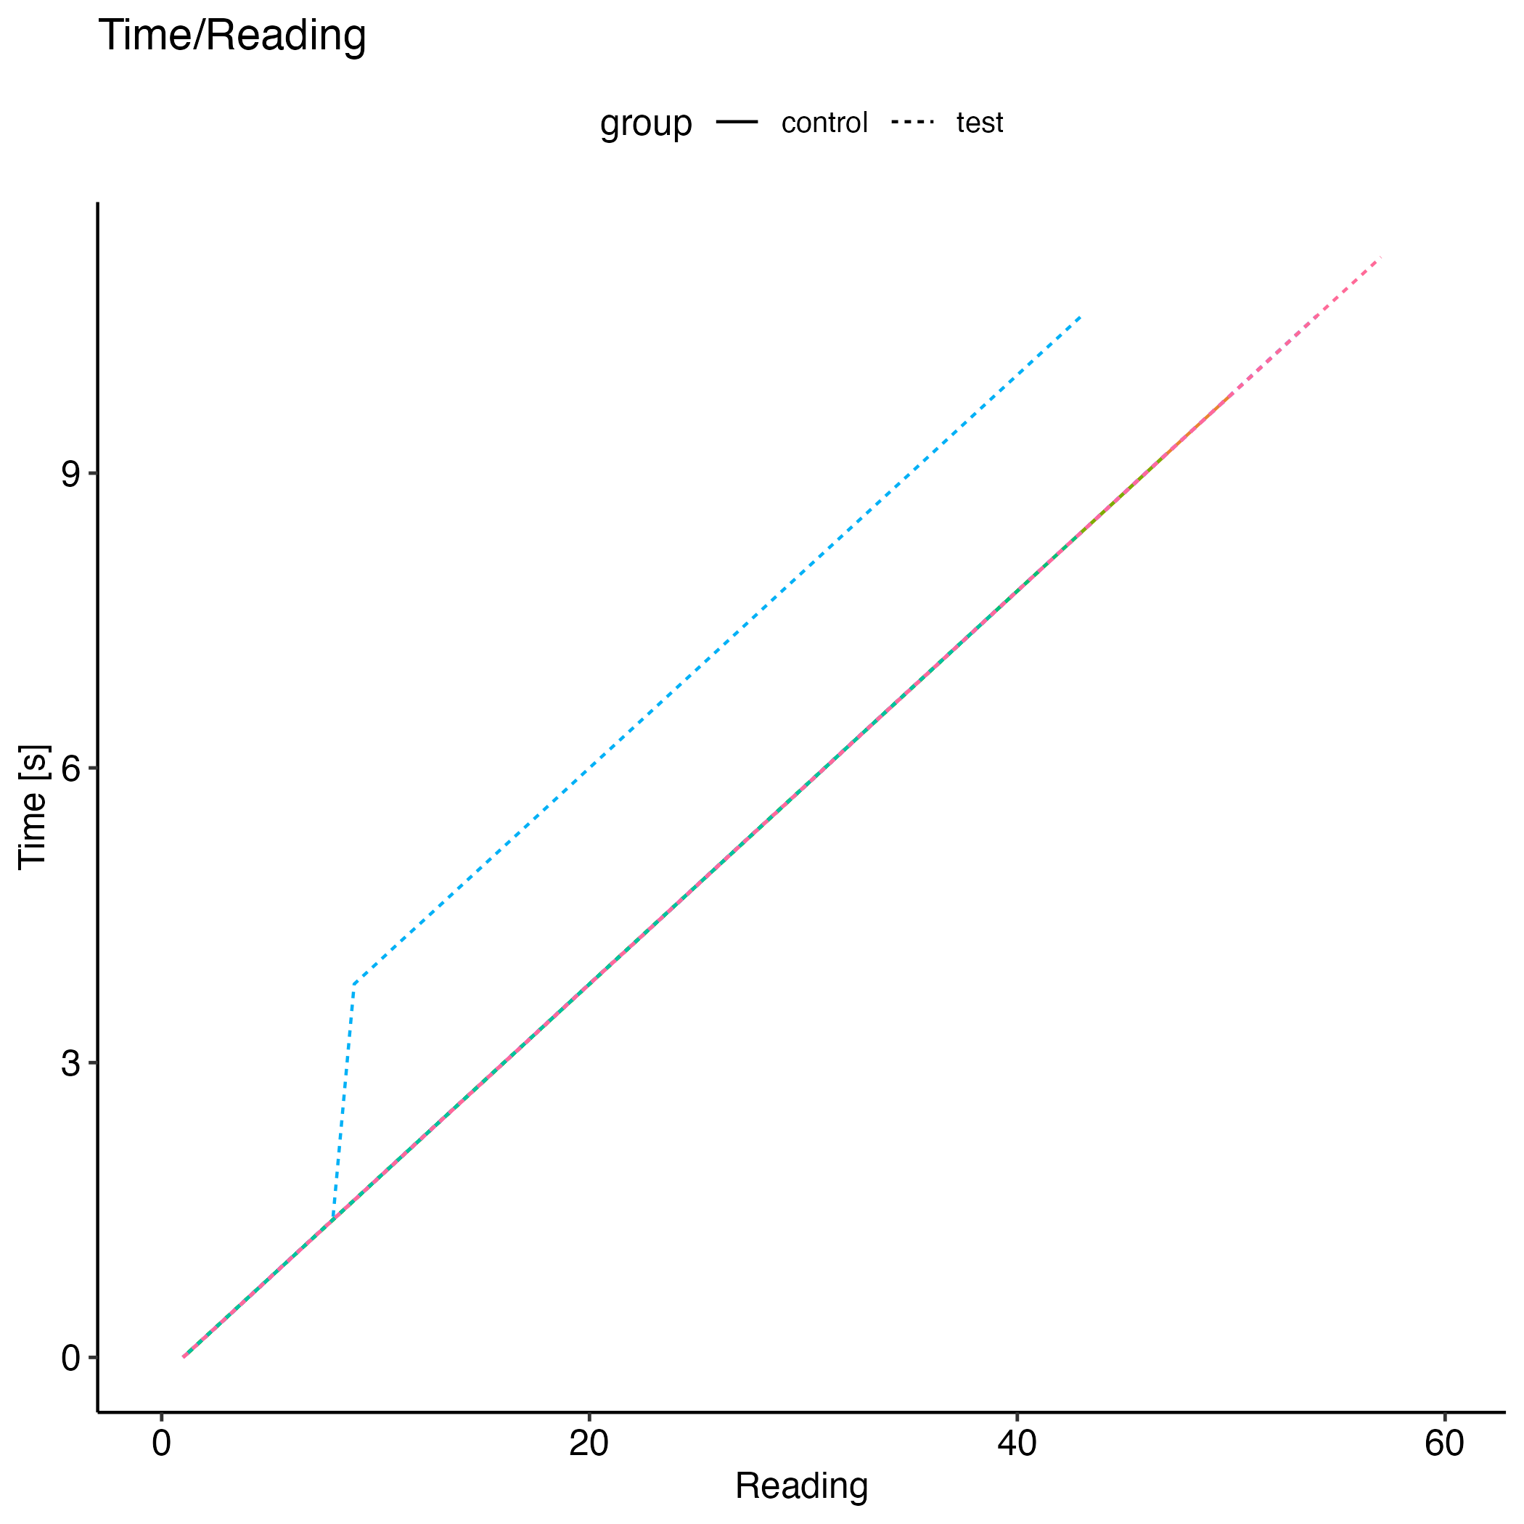
Figure 1: Validation of the biomechanical testing during this experiment.

Results
A total of 20 screws were tested, with 10 screws in the control arm and 10 screws in the testing arm. One screw from each arm was excluded from analysis due to errors in data collection (Screw 05 and Screw 13) leaving a total of 18 screws for analysis. These screws are still demonstrated in Figs 1-3 for transparency. The mean pullout strength was 760N ± 70 for the control arm (n=9) and 725N ± 66 for the testing arm (n=9). A Welch two-sample t-test showed no statistically significant difference in mean pullout strength between the two arms (p=0.3). The mean stiffness was 538 N/mm ± 83 for the control arm and 539 N/mm ± 133 for the testing arm. A Welch two-sample t-test revealed no statistically significant difference in mean stiffness between the two arms (p>0.9). Finally, the mean strain energy was 1,821 Nmm ± 445 for the control arm and 1,823 Nmm ± 327 for the testing arm. Again, a Welch two-sample t-test showed no statistically significant difference between the two arms (p>0.9).
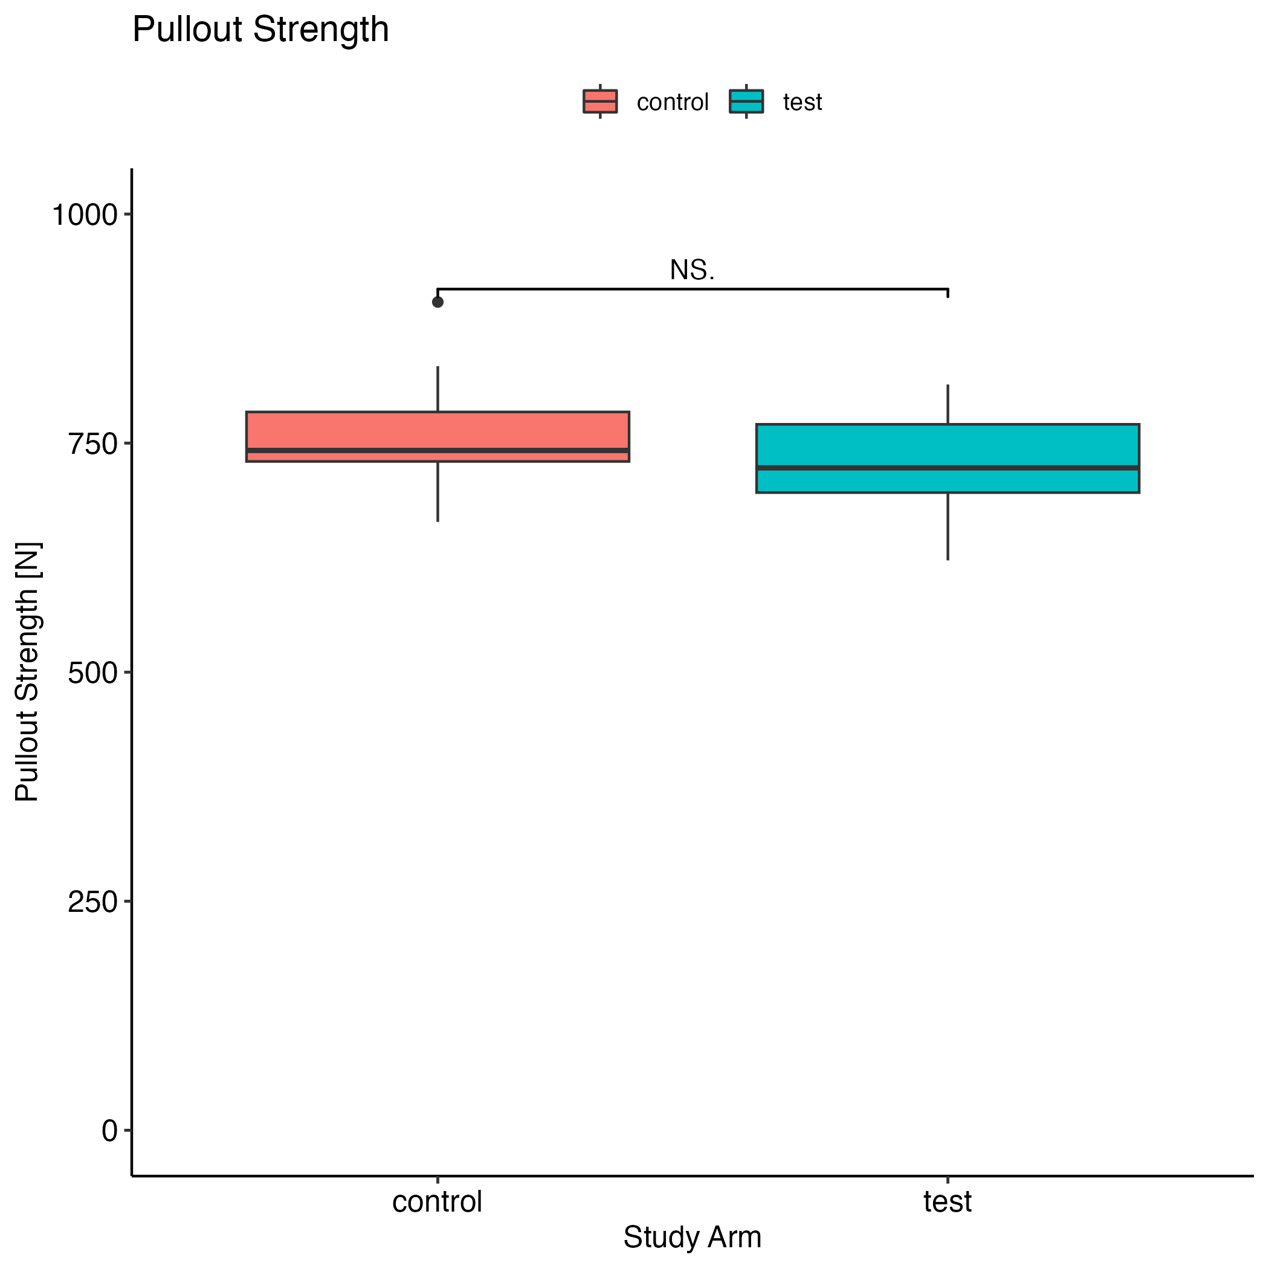 | 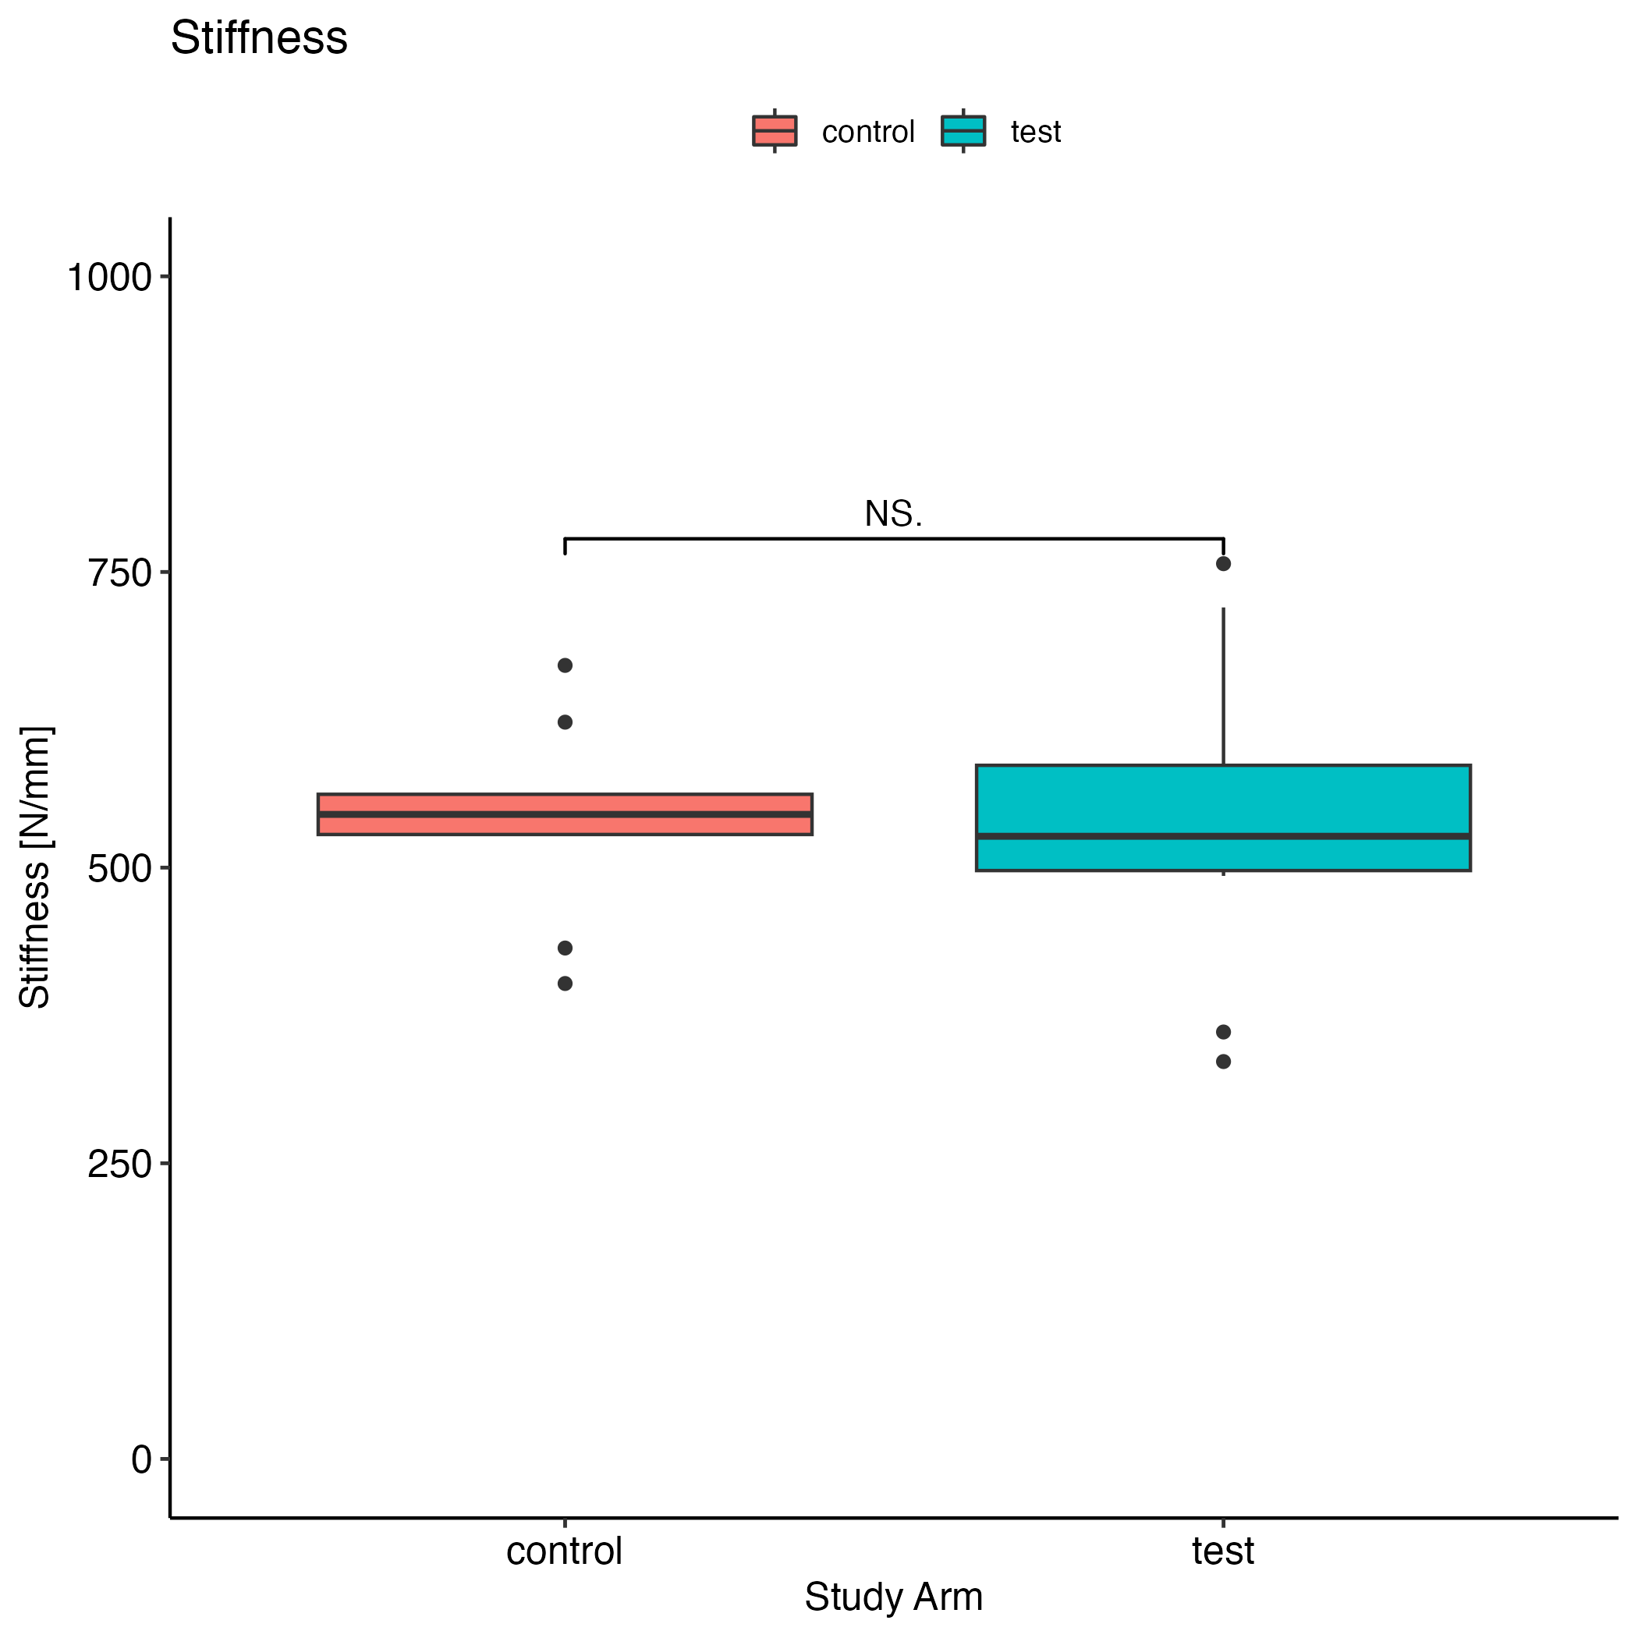 | 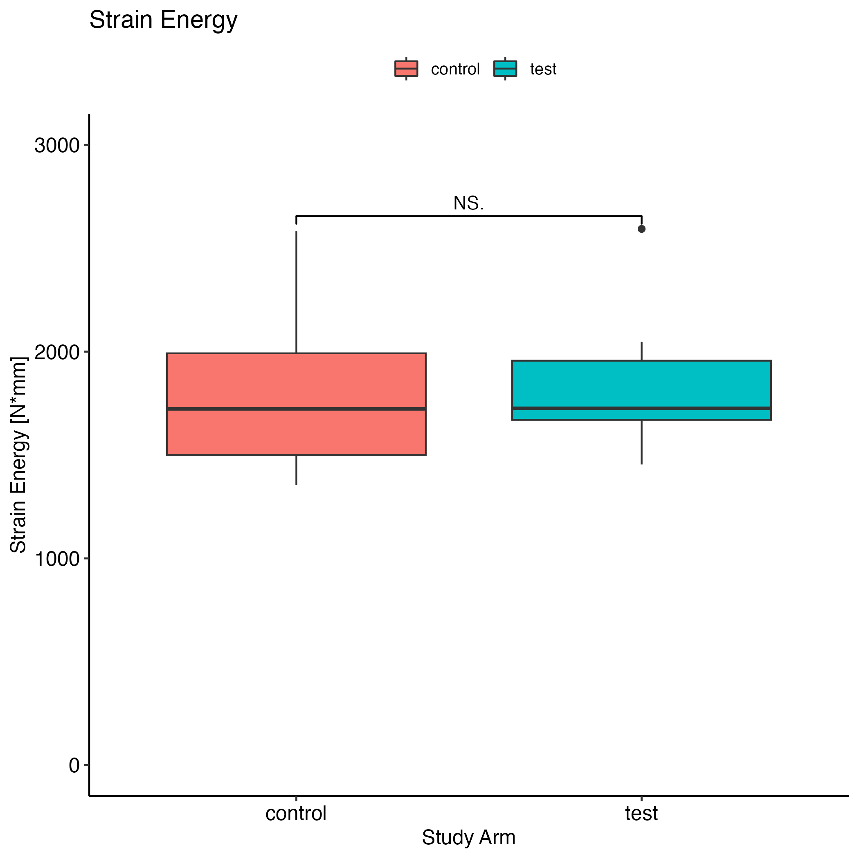
Figure 2: Mean pullout strength, stiffness, and strain energy for the control and testing arms. There was no statistically significant difference between the two arms for any of the three parameters.

Discussion
Biomechanical analyses are by no means new, underpin many of the advancements in spine surgery, and are largely under-appreciated and underutilized. Our study shows definitively that there is no difference in pullout strength in a healthy volunteer vertebral body when a screw is removed and reinserted along the same track The under-utilization biomechanical studies could be explained by the poor precision and reproducibility of results as demonstrated by the wide variety of types of materials used calf, pig, cadaver vertebrae that has been frozen or heated, or recent non-reproducible synthetic materials that have been proposed. The huge standard deviations present that have likely held back research progression due to the inability to assess significant small factors that could have an additive effect overall. Similar studies investigating reinsertion pullout have shown largely consistent but still conflicting results. Our study provides clarity and further validation of a reproducible, cost-effective model, that can serve as a template for models internationally. Limitations include the number of screws, and the lack of accounting for BMD differences as this model is not intended to demonstrate osteoporosis or sclerotic bone, but instead a normal healthy volunteer as demonstrated by our comparable pullout strengths to these other studies.

Conclusion
This study provides strongly compelling evidence that removal of a screw prior to its reinsertion along the same trajectory and to the same depth, does not diminish the pullout strength of the screw. The 3D printed model used demonstrates comparable biomechanical properties to the literature which consists of human cadaver or animal vertebrae, but with much improved reliability, reproducibility, and capability for standardization.

References
- Bohl MA, Mauria R, Zhou JJ, et al. The Barrow Biomimetic Spine: Face, Content, and Construct Validity of a 3D-Printed Spine Model for Freehand and Minimally Invasive Pedicle Screw Insertion. Global Spine Journal. 2019;9(6):635-641. doi:10/gsmt5s
- Bohl MA, McBryan S, Nakaji P, Chang SW, Turner JD, Kakarla UK. Development and first clinical use of a novel anatomical and biomechanical testing platform for scoliosis. J Spine Surg. 2019;5(3):329-336. doi:10/gsmt46
- Bohl MA, Mooney MA, Repp GJ, et al. The Barrow Biomimetic Spine: Comparative Testing of a 3D-Printed L4-L5 Schwab Grade 2 Osteotomy Model to a Cadaveric Model. Cureus. 2018;10(4). doi:10/gsmt33
- Bohl MA, Mooney MA, Repp GJ, et al. The Barrow Biomimetic Spine: Fluoroscopic Analysis of a Synthetic Spine Model Made of Variable 3D-printed Materials and Print Parameters. Spine. 2018;43(23):E1368. doi:10/gsmt5w
- Brasiliense LBC, Lazaro BCR, Reyes PM, et al. Characteristics of immediate and fatigue strength of a dual-threaded pedicle screw in cadaveric spines. The Spine Journal. 2013;13(8):947-956. doi:10/f2mvb9
- Brasiliense LBC, Theodore N, Lazaro BCR, et al. Quantitative analysis of misplaced pedicle screws in the thoracic spine: how much pullout strength is lost?: Presented at the 2009 Joint Spine Section Meeting. Journal of Neurosurgery: Spine. 2010;12(5):503-508. doi:10/bvv4km
- Cheng WK, Akpolat YT, İnceoğlu S, Danisa OA. Pedicle screws with modular head vs. preassembled head used in cortical bone trajectory: Can pars and pedicle fractures be prevented in osteoporotic bone? J Clin Neurosci. 2018;47:304-310. doi:10.1016/j.jocn.2017.09.012
- Cho W, Cho SK, Wu C. The biomechanics of pedicle screw-based instrumentation. The Journal of Bone & Joint Surgery British Volume. 2010;92-B(8):1061-1065. doi:10/fqdmwt
- Deniz FE, Brasiliense LBC, Lazaro BCR, et al. Biomechanical evaluation of posterior thoracic transpedicular discectomy. J Neurosurg Spine. 2010;13(2):253-259. doi:10/bh24x2
- Gaines RW. The Use of Pedicle-Screw Internal Fixation for the Operative Treatment of Spinal Disorders*: The Journal of Bone and Joint Surgery-American Volume. 2000;82(10):1458-1476. doi:10/gmfcmp
- Gajavelli S, Gee A, Bagheri ZS, et al. A 20-Year Review of Biomechanical Experimental Studies on Spine Implants Used for Percutaneous Surgical Repair of Vertebral Compression Fractures. Biomed Res Int. 2022;2022:6015067. doi:10/gsmt6r
- Goda Y, Higashino K, Toki S, et al. The Pullout Strength of Pedicle Screws Following Redirection After Lateral Wall Breach or End-plate Breach. Spine. 2016;41:1218-1223. doi:10/f8x4vv
- Gonzalez-Blohm SA, Doulgeris JJ, William E. Lee III, Shea TM, Aghayev K, Vrionis FD. The Current Testing Protocols for Biomechanical Evaluation of Lumbar Spinal Implants in Laboratory Setting: A Review of the Literature. BioMed Research International. 2015;2015. doi:10/f7bgz3
- Huang X, Huang Z, Xu L, Liang D, Zhang M, Zhang H. Pullout strength of reinserted pedicle screws using the previous entry point and trajectory. Journal of Orthopaedic Surgery and Research. 2019;14(1):205. doi:10.1186/s13018-019-1240-8
- Inceoglu S, Ferrara L, McLain RF. Pedicle screw fixation strength: pullout versus insertional torque. Spine J. 2004;4(5):513-518. doi:10.1016/j.spinee.2004.02.006
- İnceoğlu S, Montgomery WH, Clair SS, McLain RF. Pedicle screw insertion angle and pullout strength: comparison of 2 proposed strategies: Laboratory investigation. Journal of Neurosurgery: Spine. 2011;14(5):670-676. doi:10/b9nrj3
- Kalemci O, Kizmazoglu C, Ozyoruk S, et al. What is the Effect of Pedicle Screw Reinsertion Through the Same Trajectory on Pullout Strength? Turk Neurosurg. 2022;32(4):635-640. doi:10/gr2bn3
- Kang DG, Lehman RAJ, Wagner SC, et al. Pedicle screw reinsertion using previous pilot hole and trajectory does not reduce fixation strength. Spine (Phila Pa 1976). 2014;39(20):1640-1647. doi:10/f6h6gt
- Karami KJ, Buckenmeyer LE, Kiapour AM, et al. Biomechanical evaluation of the pedicle screw insertion depth effect on screw stability under cyclic loading and subsequent pullout. J Spinal Disord Tech. 2015;28(3):E133-139. doi:10.1097/BSD.0000000000000178
- Kim SJ, Mobbs RJ, Natarajan P, Fonseka RD, Walsh WR. Historical Note: The Evolution of Cortical Bone Trajectory and Associated Techniques. Spine Surg Relat Res. 2021;6(1):1-9. doi:10/gsmt9b
- Krishnan V, Varghese V, Kumar GS. Comparative Analysis of Effect of Density, Insertion Angle and Reinsertion on Pull-Out Strength of Single and Two Pedicle Screw Constructs Using Synthetic Bone Model. Asian Spine J. 2016;10(3):414-421. doi:10.4184/asj.2016.10.3.414
- Kwok AWL, Finkelstein JA, Woodside T, Hearn TC, Hu RW. Insertional Torque and Pull-out Strengths of Conical and Cylindrical Pedicle Screws in Cadaveric Bone. Spine. 1996;21(21):2429. doi:10/fhxh2j
- Lazaro BCR, Deniz FE, Brasiliense LBC, et al. Biomechanics of thoracic short versus long fixation after 3-column injury: Laboratory investigation. Journal of Neurosurgery: Spine. 2011;14(2):226-234. doi:10/c3sw6p
- Little AS, Brasiliense LBC, Lazaro BCR, Reyes PM, Dickman CA, Crawford NR. Biomechanical Comparison of Costotransverse Process Screw Fixation and Pedicle Screw Fixation of the Upper Thoracic Spine. Operative Neurosurgery. 2010;66(3):ons178. doi:10/bvjz3d
- Muhayudin NA, Basaruddin KS, Ijaz MF, Daud R. Finite Element Modelling of a Synthetic Paediatric Spine for Biomechanical Investigation. Materials (Basel). 2023;16(13):4514. doi:10/gsmt4m
- Pei B, Xu Y, Zhao Y, et al. Biomechanical comparative analysis of conventional pedicle screws and cortical bone trajectory fixation in the lumbar spine: An in vitro and finite element study. Front Bioeng Biotechnol. 2023;11:1060059. doi:10/gsmt68
- Varghese V, Saravana Kumar G, Krishnan V. Effect of various factors on pull out strength of pedicle screw in normal and osteoporotic cancellous bone models. Med Eng Phys. 2017;40:28-38. doi:10.1016/j.medengphy.2016.11.012
- Wang H, Wang H, Sribastav SS, et al. Comparison of pullout strength of the thoracic pedicle screw between intrapedicular and extrapedicular technique: a meta-analysis and literature review. Int J Clin Exp Med. 2015;8(12):22237-22245.
- Wilke HJ, Wenger K, Claes L. Testing criteria for spinal implants: recommendations for the standardization of in vitro stability testing of spinal implants. Eur Spine J. 1998;7(2):148-154. doi:10/drx692
- Yüksel KZ, Adams MS, Chamberlain RH, et al. Pullout resistance of thoracic extrapedicular screws used as a salvage procedure. Spine J. 2007;7(3):286-291. doi:10/cfvx8b
- Khatri R, Varghese V, Sharma S, Kumar GS, Chhabra HS. Pullout Strength Predictor: A Machine Learning Approach. Asian Spine J. 2019;13(5):842-848. doi:10/gr2bn2

